**COE848 Lab 1 (Meet Patel 500509440)**

The purpose of this project is to develop an application that will maintain a database of books. The database application will store all the necessary information required about all books. This information taken from a database will help search for specific books based on certain queries. The database will store the title of the book. It will also store the subtitle, if any in the title attribute. As Amazon rating is a good indicator about the quality of books. The database will store information about the Amazon rating of the books. It will also store the ISBN number of the books. The ISBN number is 13 digits long, and is assigned to each edition of the book. In addition to this some people have a key interest in reading fictional books over nonfiction books. Keeping this mind, the database will also store information classifying the books as fiction or nonfiction.

Furthermore, people have specific choices in the categories as mentioned above. Some people are interested in crime while others enjoy history or thriller. To meet these demands, the database will also store books based on Category. Another important factor while searching for books is cost. The database will store information about the book cost in Canadian and US dollars. Avid book readers who come across book of one author, and want to read other books of the same author. Storing names of authors in the database will help in finding the other books of the same author. Nowadays, people buy majority of their books online. However, the books cannot be delivered in all the areas. An attribute which will store the location of the book is available in, will be added to the database.

Although majority of the books are still published in English, there are many books written in many other languages. If a book is written in more than one language, the database will add information about the languages. An attribute for languages the book is available in, will be added to the database. Sometimes two different books can have the same Title. This can be sorted out by adding date the book was published in the database. Also, other basic information like weight of the book and dimensions of the book will be added to the database. Delivery companies like FedEx needs to know about the weight of the books to charge transportation(shipping-handling) prices appropriately. After the database has been conducted and developed, it will be retrieve information based on the following categories:

 

1. What are the books with the highest Amazon ratings?
2. What are the books which are fiction or nonfiction?
3. What are the books which came in some specific year?
4. What is the name of other books by the same author?
5. What are the books in specific categories (drama, crime, and thriller)?
6. What are the books which fall in certain price range?
7. What are the books which are written in some specific language?
8. What are the books which have been made into movies?
9. What are the books which has more than one author?
10. What is the book with the specific ISBN number?

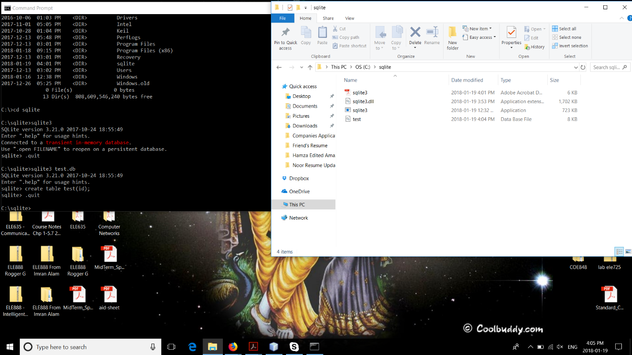

***Figure 1: SQLite installed and the files needed also downloaded.***